D1 – Simple Database – One Table
Application Development
- Understand the problem requirements elicitation:
  - Understand the element of the problem
  - Establish all details about the problem
  - Establish requirements
- Analysis initial model of the solution
  - Look for solutions
  - Choose the optimum solution
  - Create a conceptual model - !!! assignments and project
  - Create a visual model – ERD – Entity Relationship Diagram
- Design detailed model of the solution
  - Choose the implementation elements
    - Database management system
    - Other programming language that could be used for a complete application
  - Create a detailed model:
    - All variables are defined
    - All constraints are applied
    - All elements in the project well defined and ready for implementation
- Implementation complete application fully functional
  - Create tables
  - Create relationships
  - Perform queries
  - Create an interface for the application
  - Create reports
  - Create forms
- Testing – use variety of test cases to identify data sets that would create for the application
- Deployment submit the work to the beneficiary
- Maintenance and review improve the application and learn best practices
  - Solve any issues that may have appeared
  - Analyze both the application and the design process for best practices
Waterfall model
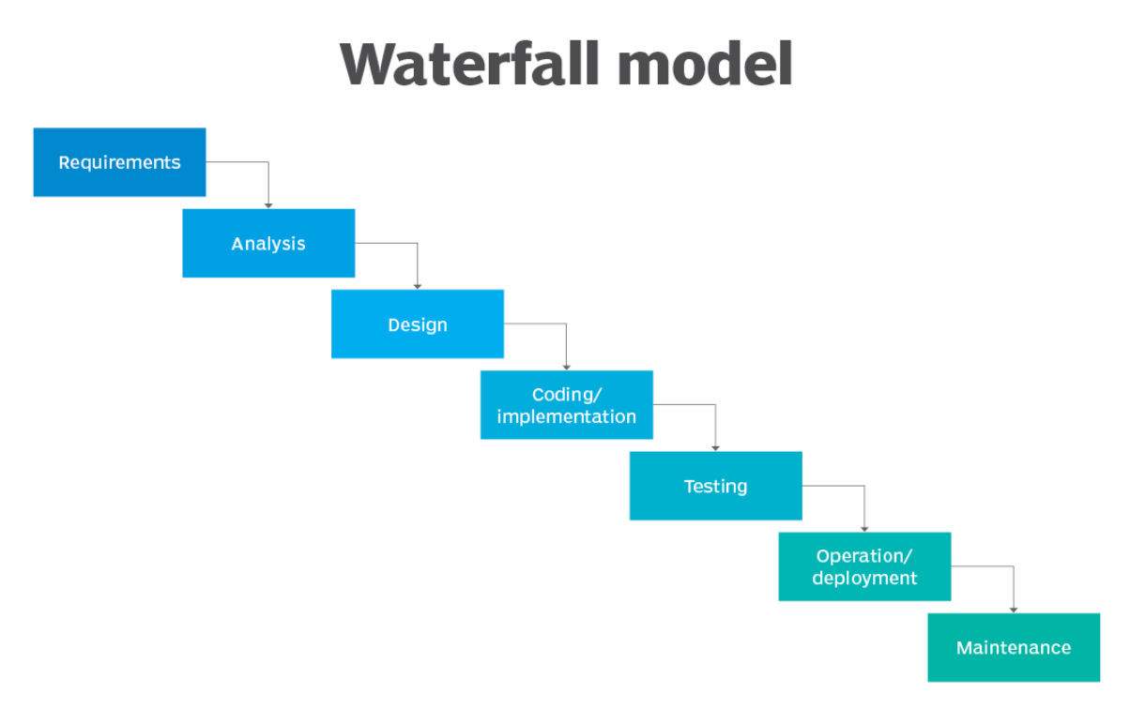
Reference: https://www.techtarget.com/searchsoftwarequality/definition/waterfall-model
Best reference in software engineering: Software Engineering. A Practitioner's Approach. Seventh Edition. Roger S. Pressman
https://intranetssn.github.io/www.ssn.net/twiki/pub/CseIntranet/CseBCS6403/PressmanBook.pdf
Database Development
Features of data:
- Visualized
- Defined
- Organized
- Accurate
- Timely
- Secure

Book resources:
Database Systems: Design, Implementation and Management by C. Coronel, S. Morris, P. Rob
https://unidel.edu.ng/focelibrary/books/Database%20Systems%20%20Design,%20Implementation,%20%20Management%20by%20Carlos%20Coronel,%20Steven%20Morris%20(z-lib.org).pdf

Application 1:
Create a database containing all information about full-time faculty members in IST of GMU.
Resource: https://ist.gmu.edu/people/faculty
- Requirement’s elicitation
  - Data required
  - Any constraints
  - Identify the features of the one table database
- Analysis
  - Finalize attributes list
  - Identify data types
  - Set specific constraints for each attribute
  - ERD
Conceptual Analysis
IST Faculty Database
Table name: IST_FACULTY
Attributes:
First Round
Name
Campus
ContactInfo
Education
Rank
Biography
Picture
ResearchInterests
AdminPosition
TenureStatus

Name conventions:
- Entity name in all upper case
- Variables
  - All upper case with words delimited by underscore
  - Camel convention – each word starting with upper case letter, all others low case
  - Snake convention – words starting with upper case and separated by _

NOTE: after first version of variables refine by decomposing those that contain multiple data

Variable names - refined
Name FirstName
MiddleName
LastName
Campus
ContactInfo EmailAddress
PhoneNumber
Building
RoomNumber
Education HighestDegree Undergraduate
UniversityName GraduateMaster
Specialty Doctoral
Rank
Biography
Picture
ResearchInterests
AdminPosition
TenureStatus

Entity Analysis
Entity Name: IST_FACULTY
Description: Entity containing the data about full-time IST faculty
Attribute Name | Variable type | Required | Duplicates | Multiple values
FacultyID | CHAR(8) | Y | N | N
FirstName | VARCHAR(15) | Y | Y | N
MiddleName | VARCHAR(15) | N | Y | N
LastName | VARCHAR(25) | Y | Y | N
Campus | VARCHAR(15) | Y | Y | N
EmailAddress | VARCHAR(30) | Y | N | N
PhoneNumber | CHAR(10) | Y | Y | N
Building | VARCHAR(30) | N | Y | N
RoomNumber | VARCHAR(6) | N | Y | N
HighestDegree | VARCHAR(12) | Y | Y | Y
University | VARCHAR(25) | Y | Y | Y
Specialty | VARCHAR(30) | Y | Y | Y
Rank | VARCHAR(25) | Y | Y | N
Biography | VARCHAR(255) | N | N | N
Picture | VARCHAR(30) | Y | N | N
ResearchInterest | VARCHAR(25) | N | Y | N
TenureStatus | VARCHAR(15) | N | Y | N
AdminPosition | VARCHAR(25) | N | Y | N

Unique identifier: Primary Key (PK) – FacultyNumber (it might be the GNumber)

Variable types:
Text:
CHAR(numberCharacters) - fix number
VARCHAR(numberCharacters) - variable with the number characters being the maximum
Numeric
INT(numberDigits)
DECIMAL(TotalNumberDigits.DecimalDigits)
Date / Time
Special types:
Links to files, images and so on.

Tool for ERD: draw.io or https://app.diagrams.net/

Entity Relationship Diagram
